**Riphah International University Gulberg Green**



**Name: AQSA KHURRAM  
Sap id: 50086  
Course: Operating System lab**

**Lab: 05**

**Task 1:**

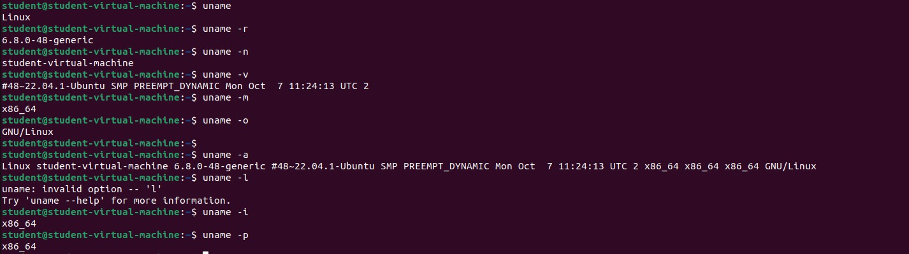

• **-r**: Displays the kernel release version.

• **-m**: Shows the machine hardware name (architecture).

• **-p**: Displays the processor type (if available).

• **-I**: Shows the hardware platform (e.g., x86_64).

• **-o**: Displays the operating system name.

• **-a**: Prints all available system information (kernel, machine, OS, etc.).

• **-v**: Displays the kernel version.

• **-n**: Displays the network node hostname.

**Task 2:**

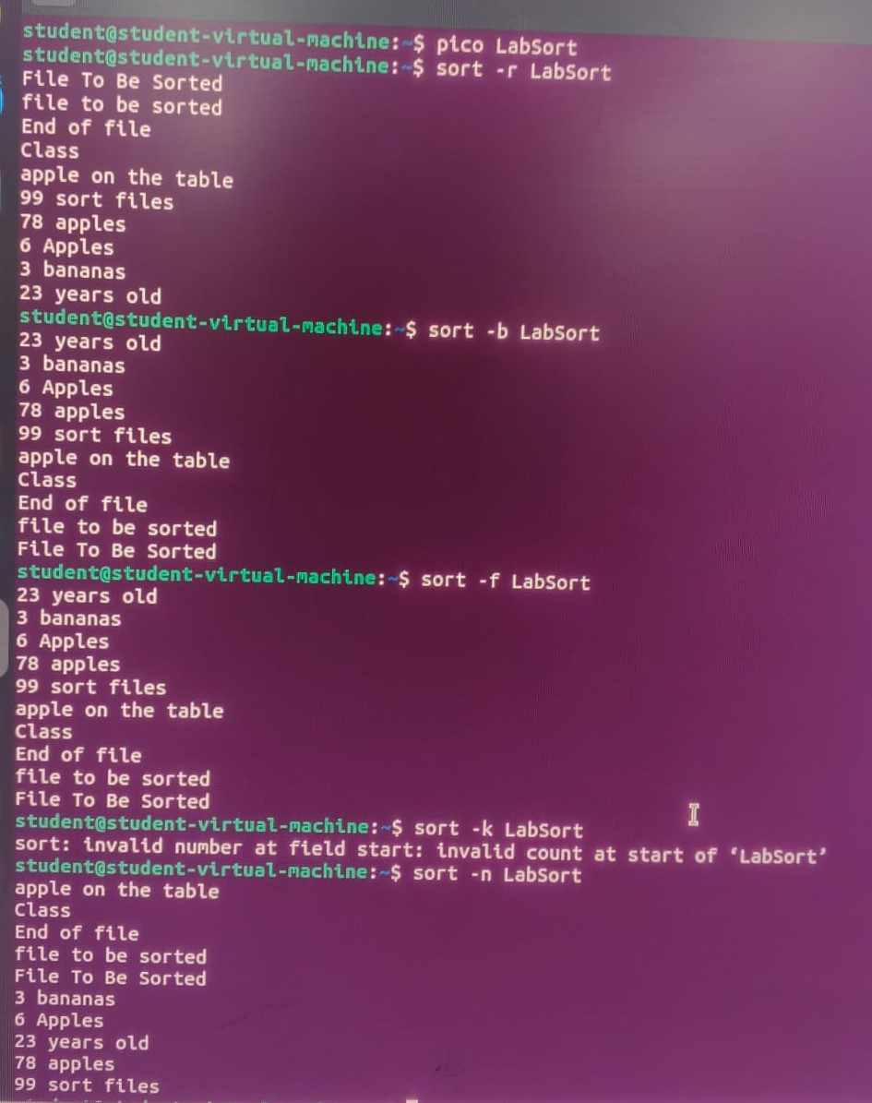

**Task 3:**

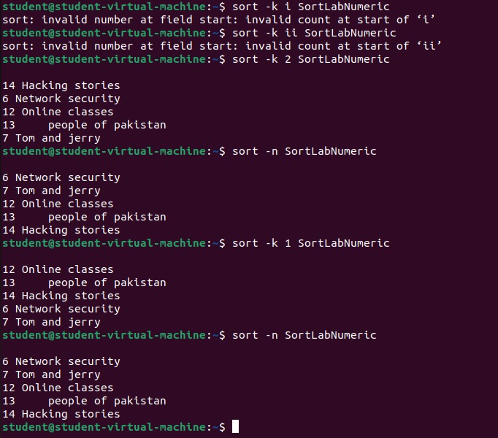

**Task 4:**

**Linux cd Command (Short):**

* cd: Go to home directory.
* cd <path>: Go to specified directory.
* cd -: Go to previous directory.
* cd ~: Go to home directory (same as cd).
* cd ..: Go up one directory.